October 9, 2019

Dear Friends,

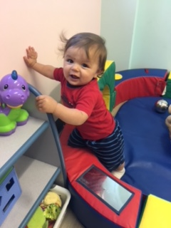
It's been said that "if you want to touch the future, touch a life," and that's precisely what happens when our community comes together for a common and united cause. The future of our residents, schools, businesses, and organizations in the Flint Hills region cannot grow and thrive if lives are not touched positively.

Touching lives by "Living Local and Giving Local" is an apt description of the work of the United Way of the Flint Hills, and is why I am honored to serve as 2019 United Way of the Flint Hills Campaign Drive Chair. I am a long-time United Way donor and currently serve on the Board of Directors. From infants, youth, young adults, adults, and the elderly, the United Way serves all by identifying issues facing our community’s residents and seeking solutions to those problems. The United Way and its 24 community partners are passionate about the work they do and those they serve.
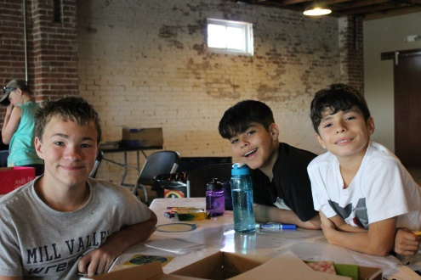
Live Local – Give Local is the theme of this year's United Way Campaign as we want you to know that the money that you donate "Stays Local!” Your past support touched the lives of thousands and thousands of people in our community. Last year $480,000 was distributed to the organizations in the counties the United Way serves.

As a recent retiree of (XX Company), I invite you to continue your support of the United Way. Retirees across the community are continuing to give to the United Way because they see the difference we are making. I hope you will join them in supporting this year’s campaign.

Thank you for your support of the United Way. I am excited and look forward to a tremendous Live Local – Give Local campaign.

Sincerely,
Ron Thomas
2019 Campaign Chair

www.uwfh.org
THANK YOU for helping people build better lives.

A CHECK is enclosed for $_____________ payable to the United Way.

CHARGE. I pledge $____________, please call me to obtain my credit card number.

Name:______________________________________________________________________________ Phone: ____________________________

Address: ________________________________________________________________________________________________________________

Former Employer: _______________________________________________________________________________________________________

